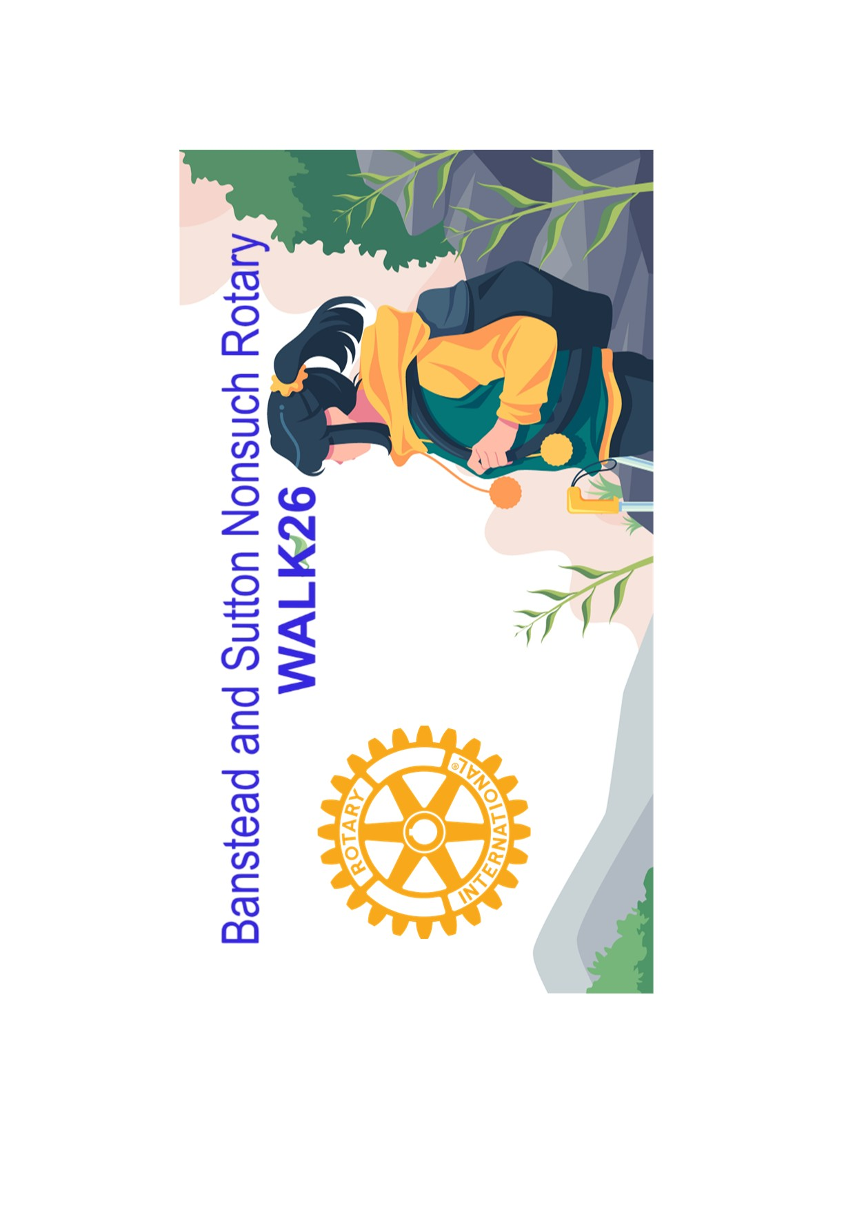

You don’t have to be a fitness enthusiast, just enjoy the outdoors and some fresh air. Here’s a great way of exercising while helping others!!

We are inviting you to join us on our Charity WALK26 over a route of about 9.0 miles. This should be manageable by parents and children alike. The event is taking place on Sunday 26th April 2026 starting between 8.30 and 10.00 am. The walk will take you through attractive North Downs scenery and starts and finishes at Tattenham Corner on Epsom Downs. There is a halfway checkpoint providing some refreshment and Marshals monitor all road crossings.

This event has proved to be an enjoyable and fun day out in past years and all funds raised are donated to charity. The Rotary Club of Banstead will donate all monies raised to various local and national charities on your behalf or you may elect to have 85% donated to your chosen charity or institution. (This can be your school, scout group, church etc).

You can enter a team (there is no limit on size). Individuals and teams raising the most money will receive certificates in recognition of their charitable efforts.

The Rotary Club of Banstead aim to help you to raise much needed funds for charity and at the same time have a very pleasant morning out in beautiful surroundings with friends and family. The walk should take about 4 hours or less to complete.
Entry and sponsor forms available online from 1st February
https://www.bansteadsuttonnonsuch.com

Sponsors can donate online (using a walker’s webpage link on GoodHub - see web link below and guidance sheet below) or by using sponsor forms.
Banstead & Sutton Nonsuch Rotary WALK26

For further information please phone or email :-

Roger de la Perrelle 07817 210691 rogerdlp06@gmail.com

David Martin 07989 405938 davidmartin 331@outlook.com

Banstead and Sutton Nonsuch CIO

Reg. Charity No. 1213139



WALK26

How to set up a fund raising page with GoodHub so that your sponsors can donate online.

Follow the link below:

Banstead & Sutton Nonsuch Rotary WALK26

Walkers wanting to raise funds for their chosen charities simply click the red Fundraise button on this page and set up a fundraising page for your chosen charity, giving the name of the charity in the title. Please follow these simple instructions:

1. Click the burgundy Fundraise button.
2. Enter your email address and create a password.
3. State the name of your chosen charity in Title.
Add a photo, if you choose, and a few lines of text.
4. An email will be sent to confirm page details and url.
Click the social media share buttons to connect with your friends and family.
5. Download your sponsorship page QR.
6. Thank you for creating your sponsor page and do have some fun entering this event.

At least 85% of funds raised will be paid to the nominated recipient. This can be a school, club, youth group, church or any other registered charity. The remaining 15% will go to Rotary charities.

Remember to encourage your sponsors to tick the Gift Aid addition, if they are able to. This can add 25% to your overall fundraising total.

Banstead and Sutton Nonsuch CIO

Reg. Charity No. 1213139

